Min / Name | Dauer / Drill / Ziel | Keypoints / Organisation
 | ❶ Ziel: .................................................................  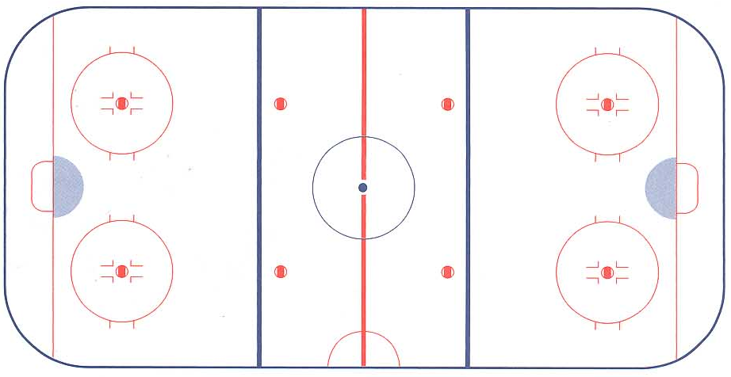 | Keypoint offensiv / defensiv
 |  | Drill-Orgaisation / Material...
Min | ❷ Ziel: .................................................................
Min | ❸: Ziel: .................................................................
Min | ❹: Ziel: .................................................................
Min | ❺: Ziel: .................................................................
Min | ❻: Ziel: .................................................................
Min | Abschluss: Drill, Game... | Oganisatorisches / Kommunikation (mental, emotional)

